**WEEK 7**

**REACT**

**IMPORTANT ADDITIONAL HANDS ON**

**13) BloogerApp**

App.jsx

import React from 'react';

import './App.css';

export const books = [

  { title: 'React Made Simple', author: 'Dan Abramov' },

  { title: 'Learning JSX', author: 'Sophie Alpert' },

  { title: 'Advanced React', author: 'Kent C. Dodds' }

];

export const blogs = [

  { topic: 'Hooks Deep Dive', writer: 'Ryan Florence' },

  { topic: 'Virtual DOM Explained', writer: 'Tom Preston' },

  { topic: 'State Management', writer: 'Mark Erikson' }

];

export const courses = [

  { name: 'React Basics', trainer: 'Tyler McGinnis' },

  { name: 'React with Redux', trainer: 'Michael Chan' },

  { name: 'React Testing', trainer: 'Debbie O’Brien' }

];

const booklet = (list) =>

  list.map((item, index) => (

    <div key={index}>

      {Object.entries(item).map(([key, value]) => (

        <p key={key}><strong>{key}:</strong> {value}</p>

      ))}

    </div>

  ));

function App() {

  return (

    <div className="App" style={{ display: 'flex', gap: '20px', padding: '20px' }}>

      <div className="st2">

        <h2>Book Details</h2>

        {booklet(books)}

      </div>

      <div className="v1">

        <h2>Blog Details</h2>

        {booklet(blogs)}

      </div>

      <div className="mystyle1">

        <h2>🎓 Course Details</h2>

        {booklet(courses)}

      </div>

    </div>

  );

}

export default App;

app.css

.App {

  font-family: Arial, sans-serif;

}

.st2 {

  background-color: #f1f9ff;

  border: 1px solid #00aaff;

  padding: 15px;

  border-radius: 10px;

  width: 30%;

  color: black;

}

.v1 {

  background-color: #fffbe7;

  border: 1px solid #ffcc00;

  padding: 15px;

  border-radius: 10px;

  width: 30%;

  color: black;

}

.mystyle1 {

  background-color: #e7ffe7;

  border: 1px solid #00cc66;

  padding: 15px;

  border-radius: 10px;

  width: 30%;

  color: black;

}

h2 {

  margin-top: 0;

  color: #333;

}

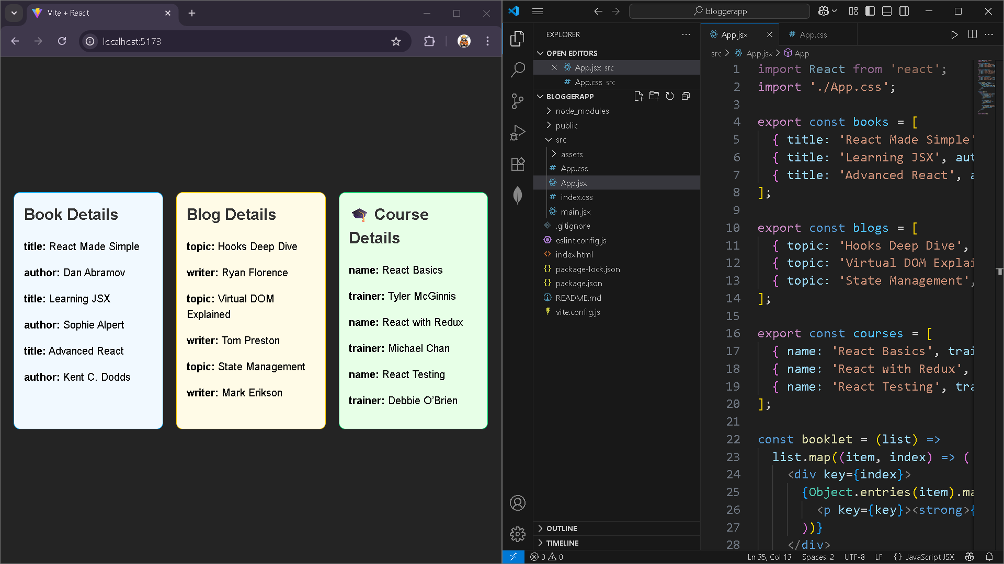

**14) EmployeeApp**

**EmployeeCard.js**

import Styles from './EmployeeCard.module.css';

import { useContext } from 'react';

import ThemeContext from './ThemeContext';

function EmployeeCard(props) {

    const theme = useContext(ThemeContext); // using context

    return (

        <div className={Styles.Card}>

            <h3>{props.employee.name}</h3>

            <p>{props.employee.email}</p>

            <p>{props.employee.phone}</p>

            <p>

                <a href="#" className={theme}>Edit</a>

                <a href="#" className={theme}>Delete</a>

            </p>

        </div>

    );

}

export default EmployeeCard;

**ThemeContext.js**

import React from 'react';

// Create a context with default value 'light'

const ThemeContext = React.createContext('light');

export default ThemeContext;

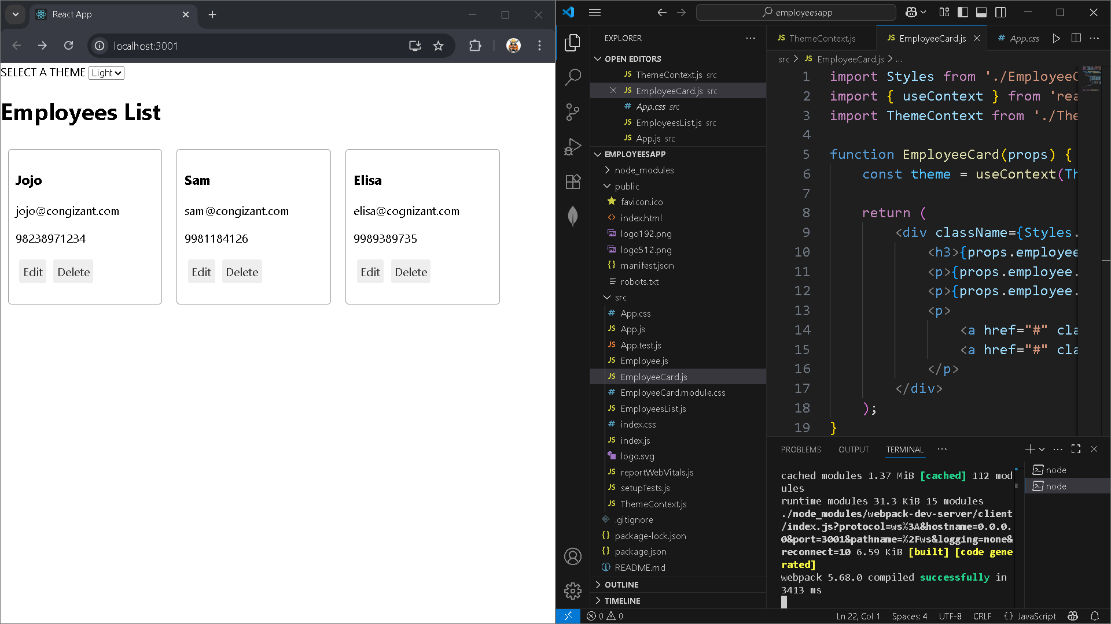

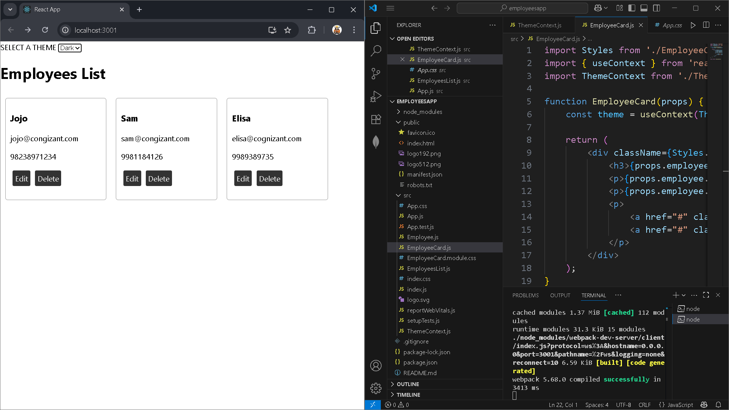

15) Ticketraisingapp

ComplaintResgister.js

import React, { useState } from 'react';

function ComplaintRegister() {

  const [employeeName, setEmployeeName] = useState('');

  const [complaint, setComplaint] = useState('');

  const handleSubmit = (e) => {

    e.preventDefault();

    if (employeeName.trim() === '' || complaint.trim() === '') {

      alert('Please fill out both fields.');

      return;

    }

    // Generate a random reference number (e.g., TKT12345)

    const referenceNumber = 'TKT' + Math.floor(10000 + Math.random() * 90000);

    alert(`Complaint submitted!\nReference Number: ${referenceNumber}`);

    // Reset form

    setEmployeeName('');

    setComplaint('');

  };

  return (

    <div style={{ maxWidth: '500px', margin: 'auto' }}>

      <h2>Raise a Complaint</h2>

      <form onSubmit={handleSubmit}>

        <div>

          <label>Employee Name:</label><br />

          <input

            type="text"

            value={employeeName}

            onChange={(e) => setEmployeeName(e.target.value)}

            style={{ width: '100%', padding: '8px' }}

          />

        </div>

        <div style={{ marginTop: '10px' }}>

          <label>Complaint:</label><br />

          <textarea

            value={complaint}

            onChange={(e) => setComplaint(e.target.value)}

            rows="4"

            style={{ width: '100%', padding: '8px' }}

          />

        </div>

        <button type="submit" style={{ marginTop: '10px' }}>

          Submit Complaint

        </button>

      </form>

    </div>

  );

}

export default ComplaintRegister;

app.js

import React from 'react';

import ComplaintRegister from './ComplaintRegister';

function App() {

  return (

    <div className="App">

      <ComplaintRegister />

    </div>

  );

}

export default App;

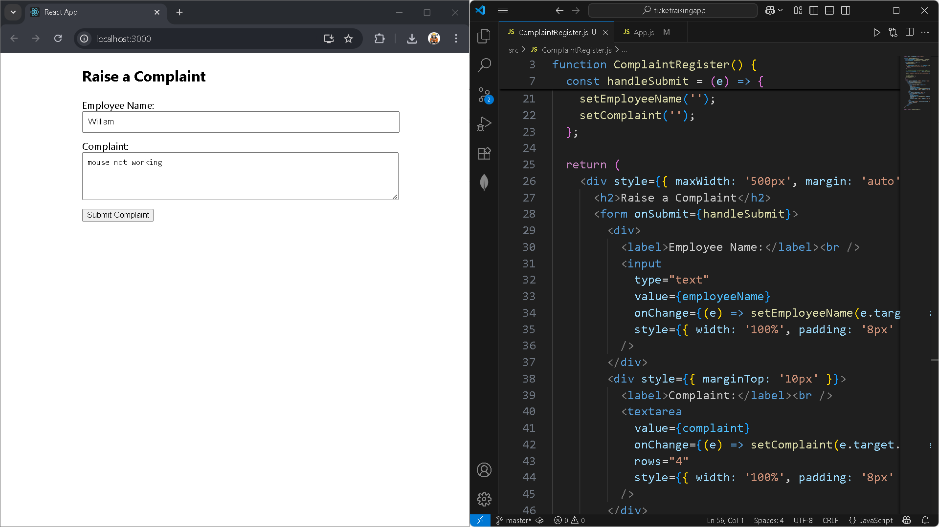

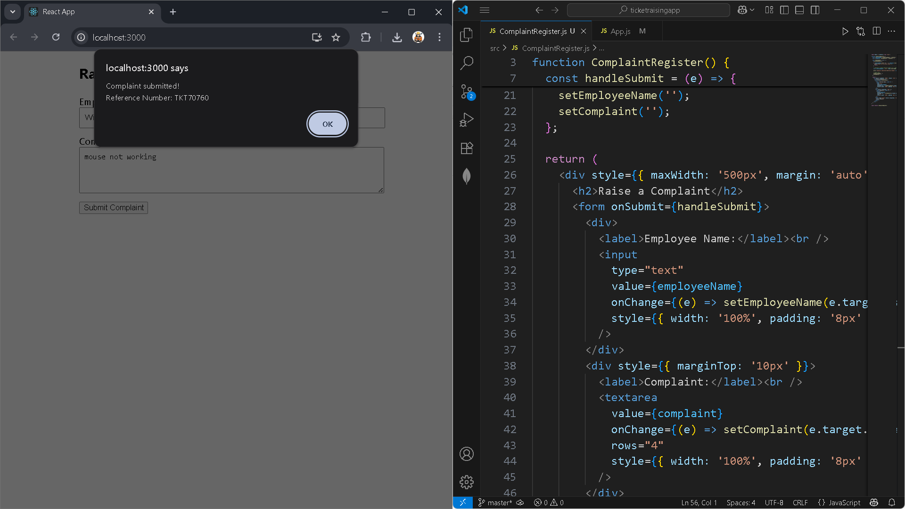

16) Mailregisterapp

Register.js

import React, { useState } from 'react';

function Register() {

  const [formData, setFormData] = useState({

    name: '',

    email: '',

    password: ''

  });

  const validate = () => {

    let errors = [];

    if (formData.name.trim().length < 5) {

      errors.push('Name must be at least 5 characters.');

    }

    if (!formData.email.includes('@') || !formData.email.includes('.')) {

      errors.push('Email must contain "@" and "."');

    }

    if (formData.password.length < 8) {

      errors.push('Password must be at least 8 characters.');

    }

    return errors;

  };

  const handleChange = (e) => {

    setFormData({ ...formData, [e.target.name]: e.target.value });

  };

  const handleSubmit = (e) => {

    e.preventDefault();

    const errors = validate();

    if (errors.length > 0) {

      alert(errors.join('\n'));  // Show all errors in one alert

    } else {

      alert('Registration successful!');

      setFormData({ name: '', email: '', password: '' });

    }

  };

  return (

    <div style={{ maxWidth: '400px', margin: 'auto' }}>

      <h2>Register</h2>

      <form onSubmit={handleSubmit}>

        <div>

          <label>Name:</label><br />

          <input

            type="text"

            name="name"

            value={formData.name}

            onChange={handleChange}

          />

        </div>

        <div>

          <label>Email:</label><br />

          <input

            type="text"

            name="email"

            value={formData.email}

            onChange={handleChange}

          />

        </div>

        <div>

          <label>Password:</label><br />

          <input

            type="password"

            name="password"

            value={formData.password}

            onChange={handleChange}

          />

        </div>

        <button type="submit" style={{ marginTop: '10px' }}>Register</button>

      </form>

    </div>

  );

}

export default Register;

app.js

import React from 'react';

import Register from './register';

function App() {

  return (

    <div className="App">

      <Register />

    </div>

  );

}

export default App;

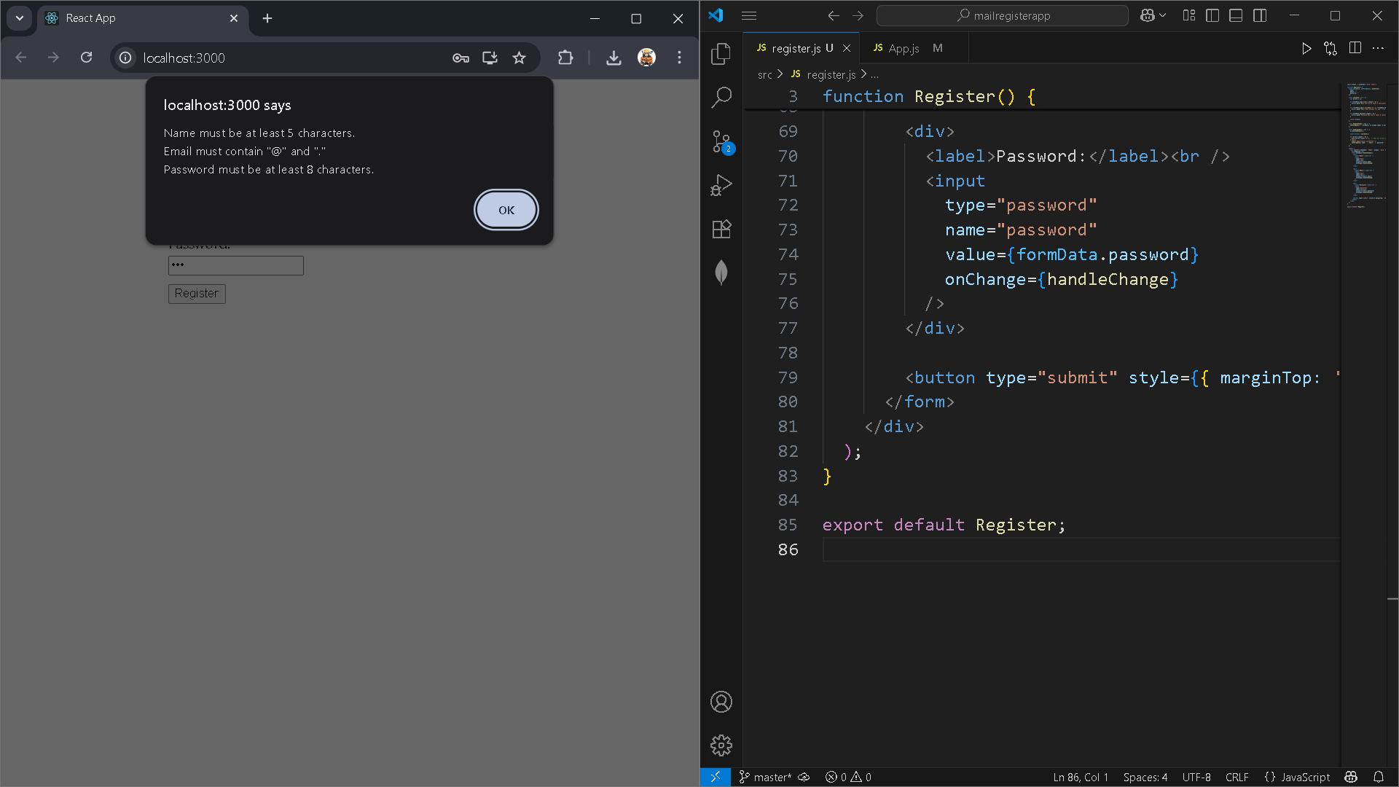

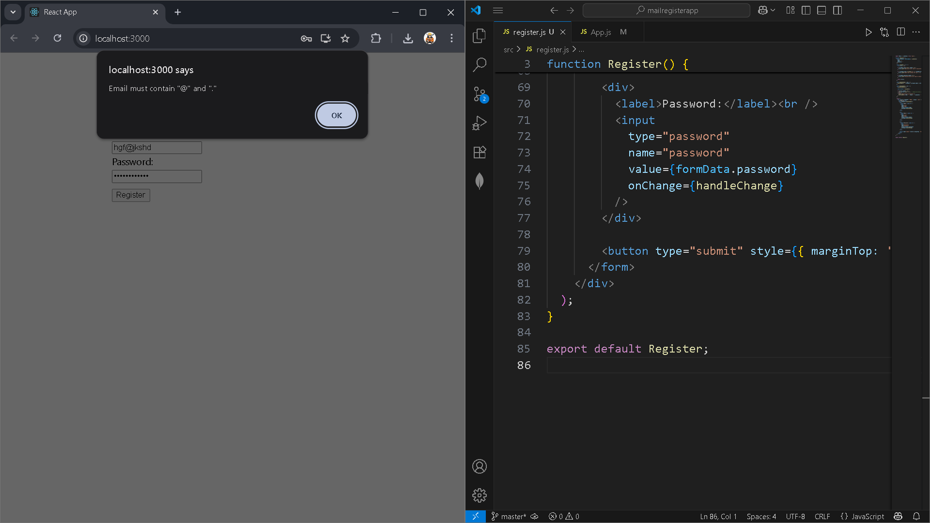

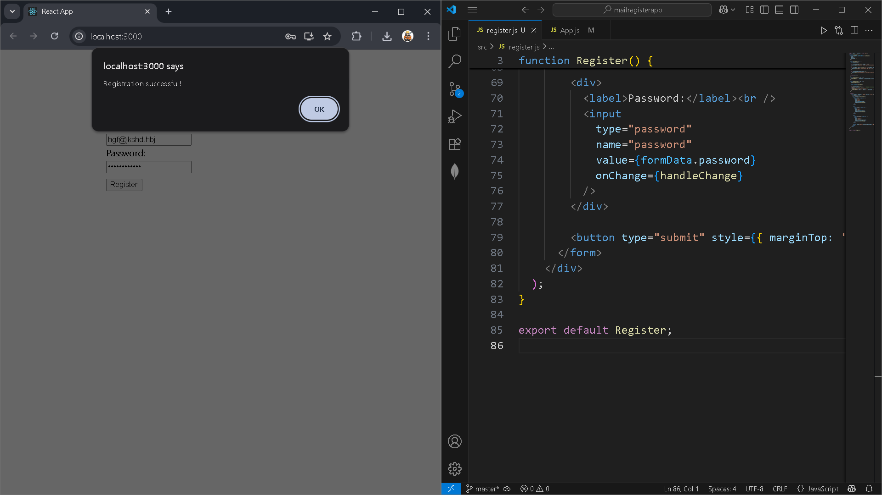

17) fetchuserapp

Getuser.js

import React, { Component } from 'react';

class Getuser extends Component {

  constructor(props) {

    super(props);

    this.state = {

      person: null,

      loading: true

    };

  }

  async componentDidMount() {

    const url = "https://api.randomuser.me/";

    const response = await fetch(url);

    const data = await response.json();

    this.setState({ person: data.results[0], loading: false });

    console.log(data.results[0]);

  }

  render() {

    const { person, loading } = this.state;

    if (loading) {

      return <h3>Loading...</h3>;

    }

    return (

      <div style={{ textAlign: 'center' }}>

        <h2>User Details</h2>

        <img src={person.picture.large} alt="User" style={{ borderRadius: '50%' }} />

        <p>{person.name.title} {person.name.first}</p>

      </div>

    );

  }

}

export default Getuser;

app.js

import React from 'react';

import Getuser from './Getuser';

function App() {

  return (

    <div className="App">

      <Getuser />

    </div>

  );

}

export default App;

